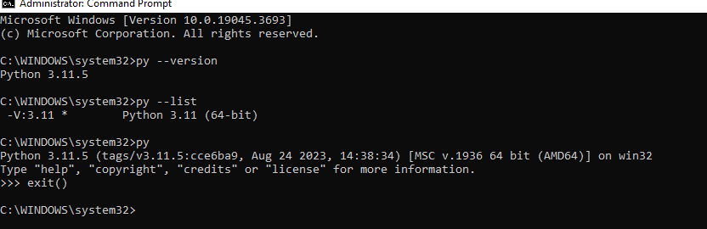

switch to specific version of python :

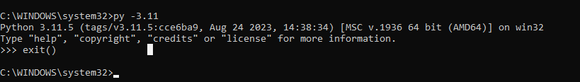

**py list paths:**



**++++++++++++++++++++++++++++++++++++++++++++++++++++++++++++++++++++++++++++++++++++++++++++++++++++++++++++++++++++++++++++++++++++++++++++++++++++**

**github link:**

<https://github.com/fbaptiste/python-fundamentals/tree/main>

**++++++++++++++++++++++++++++++++++++++++++++++++++++++++++++++++++++++++++++++++++++++++++++++++++++++++++++++++++++++++++++++++++++++++++++++++++++**

**Trying to download multiple python version :**

**++++++++++++++++++++++++++++++++++++++++++++++++++++++++++++++++++++++++++++++++++++++++++++++++++++++++++++++++++++++++++++++++++++++++++++++++++++**

[**https://www.python.org/downloads/windows/**](https://www.python.org/downloads/windows/)

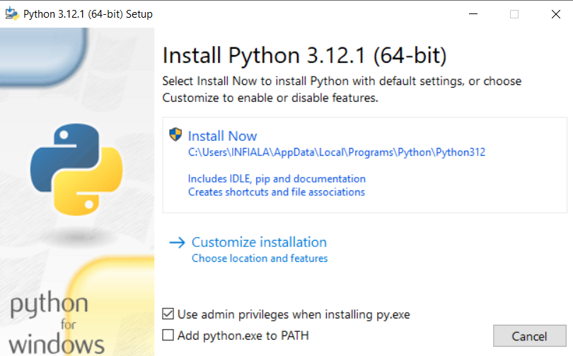

**++++++++++++++++++++++++++++++++++++++++++++++++++++++++++++++++++++++++++++++++++++++++++++++++++++++++++++++++++++++++++++++++++++++++++++++++++++**

**Now I, firoz, downloaded 3 python version :**

**++++++++++++++++++++++++++++++++++++++++++++++++++++++++++++++++++++++++++++++++++++++++++++++++++++++++++++++++++++++++++++++++++++++++++++++++++++**

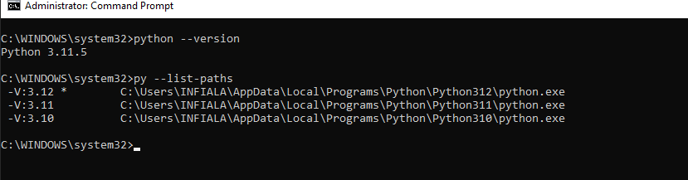

**C:\WINDOWS\system32>python --version**

**Python 3.11.5**

**C:\WINDOWS\system32>py --list-paths**

**-V:3.12 * C:\Users\INFIALA\AppData\Local\Programs\Python\Python312\python.exe**

**-V:3.11 C:\Users\INFIALA\AppData\Local\Programs\Python\Python311\python.exe**

**-V:3.10 C:\Users\INFIALA\AppData\Local\Programs\Python\Python310\python.exe**

**C:\WINDOWS\system32>py --list**

**-V:3.12 * Python 3.12 (64-bit)**

**-V:3.11 Python 3.11 (64-bit)**

**-V:3.10 Python 3.10 (64-bit)**

**Note : Python version selection can be done using setting “PY_PYTHON 3.10”**

**++++++++++++++++++++++++++++++++++++++++++++++++++++++++++++++++++++++++++++++++++++++++++++++++++++++++++++++++++++++++++++++++++++++++++++++++++++**

**create virtual env : for default version (started with * )**

**++++++++++++++++++++++++++++++++++++++++++++++++++++++++++++++++++++++++++++++++++++++++++++++++++++++++++++++++++++++++++++++++++++++++++++++++++++**

**step 1:** command = C:\Users\INFIALA\AppData\Local\Programs\Python\Python312\python.exe -m venv D:\Python\test

**Step 2: active that virtual env**

D:\Python\test\Scripts>dir

Volume in drive D is ABB

Volume Serial Number is 7E4A-193C

Directory of D:\Python\test\Scripts

12/23/2023 06:36 PM <DIR> .

12/23/2023 06:36 PM <DIR> ..

12/23/2023 06:36 PM 2,012 activate

12/23/2023 06:36 PM 983 activate.bat

12/23/2023 06:36 PM 26,199 Activate.ps1

12/23/2023 06:36 PM 393 deactivate.bat

12/23/2023 06:36 PM 108,392 pip.exe

12/23/2023 06:36 PM 108,392 pip3.12.exe

12/23/2023 06:36 PM 108,392 pip3.exe

12/23/2023 06:35 PM 270,616 python.exe

12/23/2023 06:35 PM 259,352 pythonw.exe

9 File(s) 884,731 bytes

2 Dir(s) 43,654,324,224 bytes free

D:\Python\test\Scripts>activate

(test) D:\Python\test\Scripts>

(test) D:\Python\test\Scripts>deactivate

D:\Python\test\Scripts>

**++++++++++++++++++++++++++++++++++++++++++++++++++++++++++++++++++++++++++++++++++++++++++++++++++++++++++++++++++++++++++++++++++++++++++++++++++++**

**create virtual env (other version and not default as above )**

**++++++++++++++++++++++++++++++++++++++++++++++++++++++++++++++++++++++++++++++++++++++++++++++++++++++++++++++++++++++++++++++++++++++++++++++++++++**

**earlier 3.12 python created but here below 3.10 .**

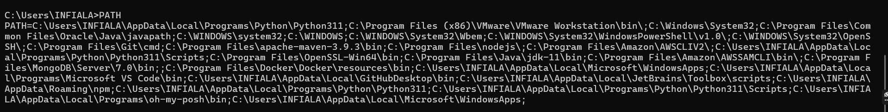

**D:\Python>py -3.10 -m venv firozpython3_10**

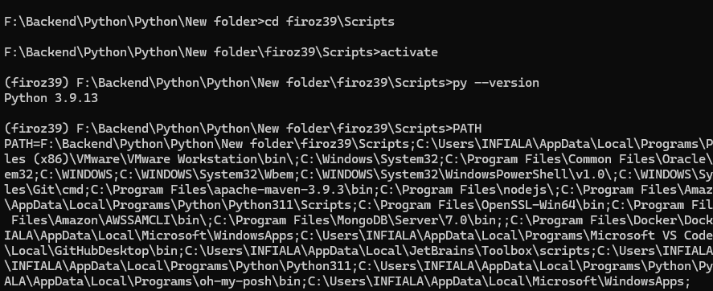

**In the above snapshot we can see , once the path**

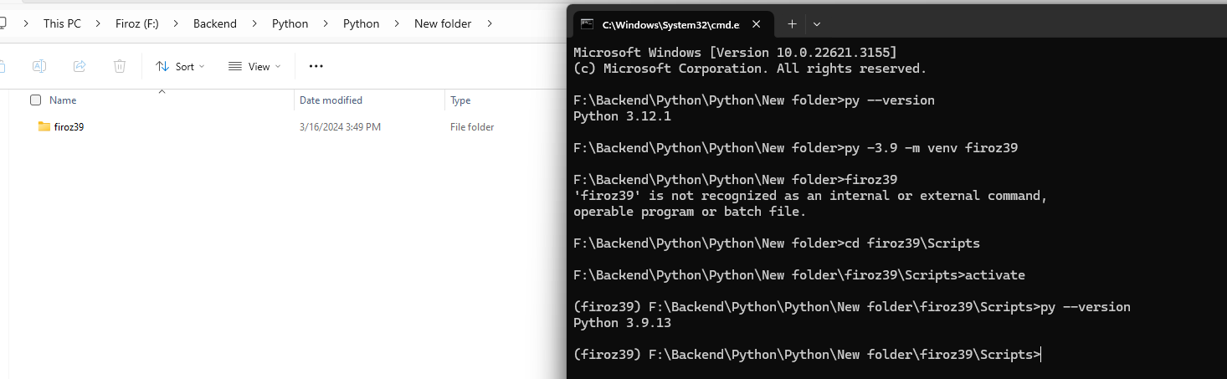

**++++++++++++++++++++++++++++++++++++++++++++++++++++++++++++++++++++++++++++++++++++++++++++++++++++++++++++++++++++++++++++++++++++++++++++++++++++**

**pip freeze == > it will give you list of all packages downloaded in virtual env**

**++++++++++++++++++++++++++++++++++++++++++++++++++++++++++++++++++++++++++++++++++++++++++++++++++++++++++++++++++++++++++++++++++++++++++++++++++++**

**++++++++++++++++++++++++++++++++++++++++++++++++++++++++++++++++++++++++++++++++++++++++++++++++++++++++++++++++++++++++++++++++++++++++++++++++++++**

**How to open jupyter notebook**

**++++++++++++++++++++++++++++++++++++++++++++++++++++++++++++++++++++++++++++++++++++++++++++++++++++++++++++++++++++++++++++++++++++++++++++++++++++**



**++++++++++++++++++++++++++++++++++++++++++++++++++++++++++++++++++++++++++++++++++++++++++++++++++++++++++++++++++++++++++++++++++++++++++++++++++++**

**Installing packages**

**++++++++++++++++++++++++++++++++++++++++++++++++++++++++++++++++++++++++++++++++++++++++++++++++++++++++++++++++++++++++++++++++++++++++++++++++++++**

[**https://pypi.org**](https://pupi.org) **→ here all python packages present**

**PIP install package_name .(but here where the packages would be downloaded) , so for that we need to set venv first otherwise i think in the default python , it will be installed .**

**pip install package_name == 1.3.1**

**pip install package_name <= 1.3.1**

**pip install package_name > 2.1**

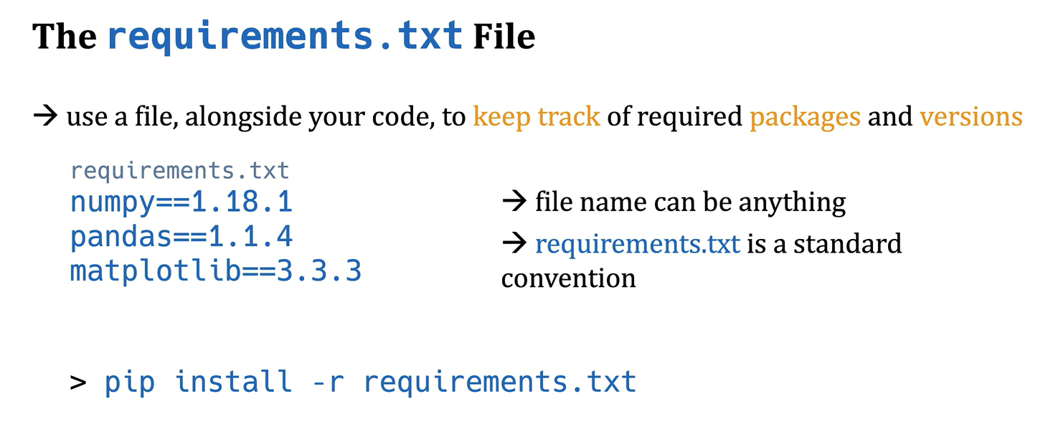

**++++++++++++++++++++++++++++++++++++++++++++++++++++++++++++++++++++++++++++++++++++++++++++++++++++++++++++++++++++++++++++++++++++++++++++++++++++**

**Python Basics Topics**

**++++++++++++++++++++++++++++++++++++++++++++++++++++++++++++++++++++++++++++++++++++++++++++++++++++++++++++++++++++++++++++++++++++++++++++++++++++**

**Python Basics**

* **What is Python**
* **How to install Python**
* **How to create and use virtual environments**
* **How to run Python and Jupyter notebooks**
* **Basic data types including integers, floats, booleans**
* **Boolean operators**
* **Arithmetic and comparison operators, as well as operator precedence**
* **Conditional execution**
* **Looping (for and while)**
* **Sequence types such as lists, tuples and strings**
* **Working with sequence types (iterating, slicing, manipulating, copying, unpacking)**
* **More on strings and Unicode**
* **Dictionaries and sets**
* **Python's list, dictionary and set comprehensions**
* **Exceptions and exception handling**
* **Iterables and iterators, including generators**
* **Writing user defined functions and different ways of defining and passing arguments**
* **Lambda functions**
* **Some of Python's built-in functions (such as zip, sorted, min, max, and round)**

**Intermediate Python**

* **Higher order functions (passing and returning functions from functions)**
* **Maps (dictionaries)**
* **Closures**
* **Advanced sorting and filtering**
* **Decorators - what they are, and how to write your own**
* **Reading and writing text files**
* **Python's module and import system**
* **How to work with dates and times**
* **How to read and write CSV files**
* **Random numbers and sampling**
* **A look at Python Math and Stats modules**
* **Decimal data type - for when floats aren't precise enough**
* **How to write your own custom Classes (OOP)**

**3rd Party Libraries**

* **the *pytz* library for dealing with timezones and daylight savings**
* **the *dateutil* library for parsing date/time strings**
* **What is JSON data, and how to read and write JSON**
* **What are REST APIs**
* **How to use the *requests* library for HTTP/s requests (and how to interact with a REST API)**
* **Fundamentals of the *NumPy* library for fast numerical computations**
* **Fundamentals of the *Pandas* library for working with data sets (including indexing)**
* **Fundamentals of the *matplotlib* library for charting data**

**++++++++++++++++++++++++++++++++++++++++++++++++++++++++++++++++++++++++++++++++++++++++++++++++++++++++++++++++++++++++++++++++++++++++++++++++++++**

**OOPS Topics**

**++++++++++++++++++++++++++++++++++++++++++++++++++++++++++++++++++++++++++++++++++++++++++++++++++++++++++++++++++++++++++++++++++++++++++++++++++++**

* **Python Object Oriented Concepts**
* **Classes**
* **Methods and Binding**
* **Instance, Class and Static Methods**
* **Properties**
* **Property Decorators**
* **Single Inheritance**
* **Slots**
* **Descriptors**
* **Enumerations**
* **Exceptions**
* **Metaprogramming**

**Hello everyone, new Python content on my YouTube channel on a variety of topics:**

**Pythonic Code: Iterating Dictionaries**

[**https://www.youtube.com/watch?v=abOxepN_Fc0**](https://www.youtube.com/watch?v=abOxepN_Fc0)

**Pythonic Code: Decomposition and Refactoring Exercise**

[**https://www.youtube.com/watch?v=AtcWP8LZoLo**](https://www.youtube.com/watch?v=AtcWP8LZoLo)

**Pythonic Code: Generators**

[**https://www.youtube.com/watch?v=L6KYYeN5VfI**](https://www.youtube.com/watch?v=L6KYYeN5VfI)

**If you're looking for something on dataclasses, this is an in-depth 2 hour guide to dataclasses:**

[**https://www.youtube.com/watch?v=2P0i119GXNQ**](https://www.youtube.com/watch?v=2P0i119GXNQ)

[**https://www.youtube.com/watch?v=e_jeuDDYuOE**](https://www.youtube.com/watch?v=e_jeuDDYuOE)

**For those that might be slightly confused on the concepts of concurrent processing, parallel processing, multi-threading and asynchronous programming, this will help:**

[**https://www.youtube.com/watch?v=S05-MZAJqNM**](https://www.youtube.com/watch?v=S05-MZAJqNM)

**And for those starting with FastAPI and need to understand Pydantic data models, this is an in-depth guide to Pydantic 1.x data models:**

[**https://www.youtube.com/watch?v=gb3arRysqMo**](https://www.youtube.com/watch?v=gb3arRysqMo)

**++++++++++++++++++++++++++++++++++++++++++++++++++++++++++++++++++++++++++++++++++++++++++++++++++++++++++++++++++++++++++++++++++++++++++++++++++++**

**Confusing things**

**++++++++++++++++++++++++++++++++++++++++++++++++++++++++++++++++++++++++++++++++++++++++++++++++++++++++++++++++++++++++++++++++++++++++++++++++++++**

